# Reexam 2023-2024

Indholdsfortegnelse

Reexam 2023-2024 1

Problem 1 - Super position and system characteristics 2

1. Recreate from two signals starting by using 2

2. CT / DT, Periodic + Fundamental period / nonperiodic 3

3. Memoryless, causal, TI / LTI? 3

Problem 2 - Signal through LTI system.¨ 4

1. Sketch the signals and 4

2. Compute 4

3. Sketch 5

1. Sketch 6

2. Compute 6

3. Sketch 7

Problem 3 - Fourier transform of a CT signal. 8

1. Sketch 8

2. Compute the Fourier transform using the analysis equation. 8

3. Express the magnitude 9

4. Sketch the magnitude 10

Problem 4 - Differential and difference equations 10

1. Determine the frequency response of the CTLTI system 10

2. Plot the frequency response 10

3. Determine the frequency response 11

4. Express in terms of magnitude and phase. 12

Problem 5 12

1. Determine the nyquist rate and sampling period. 12

Problem 5 - Sampling 13

## Problem 1 - Super position and system characteristics

### Recreate from two signals starting by using

The two signal will come together and make interference.

What’s needed in the signal is a one high step function from 0 to 3, some time shifting for and time scaling for g.



Which makes the times shift being 3, for the step to start at 1.

Being the first signal in the superposition.



Now for the second signal:



It should be time scaled.

Instead of doubling the signal speed, as we did in the previous signal, we want the speed of this signal to be 2/3 of the current g(t).



Now needing , for t = 0 which it becomes with: *a = -1*



Then the signal can be expressed as



==========================

==========================

### CT / DT, Periodic + Fundamental period / nonperiodic

Is a continous time periodic signal with fundamental frequency 10 and fundamental period

Is a discrete periodic signal with the fundamental period of

Is a continous time nonperiodic due to its decaying function

### Memoryless, causal, TI / LTI?

## Problem 2 - Signal through LTI system.¨

Continous system:

### Et billede, der indeholder linje/række, tekst, Parallel, diagram Automatisk genereret beskrivelseSketch the signals and

The signals are equal to

For

### Compute

With the convolution integral t becomes a time shift, and tau the variable, which is time reversed.

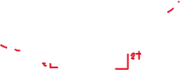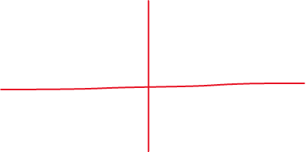

And now we look at the areas, in which the integral is nonzero.

As they are both zero before , then the integral is 0 for the region

‘’’



For

### Sketch

Discrete system

### Sketch

Setting



### Et billede, der indeholder tekst, Font/skrifttype, hvid, diagram Automatisk genereret beskrivelseCompute

The follows the same principle as the integral, but only for integer values n.

For two arrays, you can calculate all the combinations in the convolution sum by

and then summing all the diagonals into a new array.

With and taking in *n’s* from :



Calculating it to be:

Comparing it two scipy.signals fftconvole function, my calculations are just the same as theirs.



### Sketch



## Problem 3 - Fourier transform of a CT signal.

### Sketch

### Et billede, der indeholder tekst, Font/skrifttype, håndskrift, hvid Automatisk genereret beskrivelseCompute the Fourier transform using the analysis equation.

The first equation to the right being the synthesis equation and the second being the analysis equation I will then find the fourier transform.

Starting by finding its coefficients.

Assuming that the period is the time in which it’s nonzero. It could have had a period were the duty cycle wasn’t 100%, but for this problem I strongly believe, that the period I’m supposed to integrate over is

Making a script and finding the coefficients from

Now having found the coefficients, I can then put them into the synthesis equation.

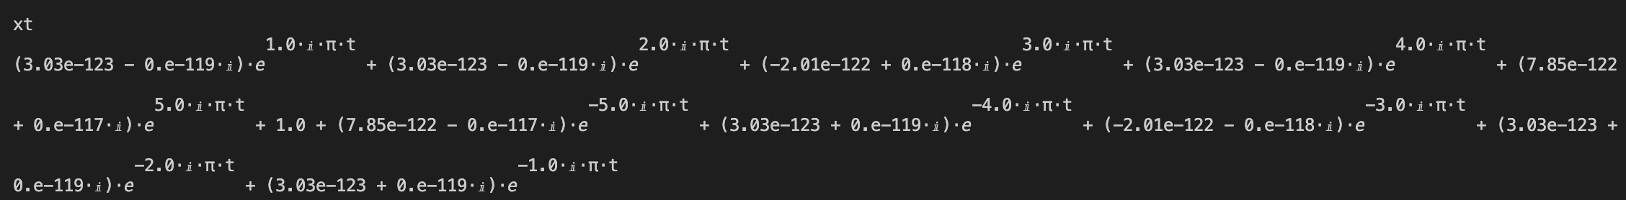================================================================================================================================================================

For

### Express the magnitude

Looping over the ak and taking for each complex ak I get.

### Sketch the magnitude

I don’t know whether the signal only depends on one k, but that’s what my calculations gave me throughout this problem.

## Problem 4 - Differential and difference equations

### Determine the frequency response of the CTLTI system

Using Laplace to find the frequency response with Time shift, Linearity and differentiation properties.

================

================

### Plot the frequency response

Here I assume that the response is wanted in db.

I will then:

The switch in phase comes from the delay of the system, which makes these alternating movements.

### Determine the frequency response

For this task I would find the frequency representation of the signal and then find the normalized frequency representation of it.

Finding the frequency representation of it I can use Z transform.

This might not work, as it seems as the system response only has a larger numerator than the denominator, the transform might be false.

### Express in terms of magnitude and phase.

## Problem 5

### Determine the nyquist rate and sampling period.

I would then find the samling period. Take the inverse of that to find the sampling rate, and the nyquist rate would then be

## Problem 5 - Sampling